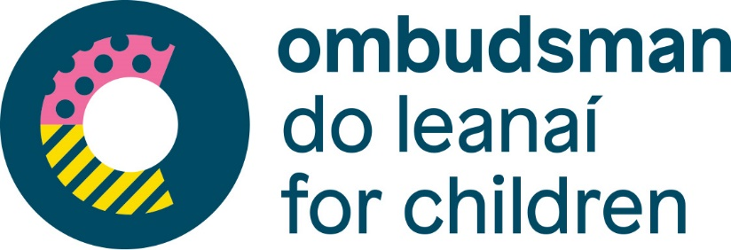

Oireachtas Joint Committee on Education, Further and Higher Education, Research, Innovation and Science
Opening Statement by the Director of Investigations at the Ombudsman for Children’s Office, Nuala Ward
Tuesday, 14th June 2022
I would like to thank the Joint Committee on Education, Further and Higher Education, Research, Innovation and Science (Committee) for the invitation to appear today to discuss the provision of education and associated supports for displaced Ukrainian students.
As members of the Committee are aware, the Ombudsman for Children’s Office (OCO) is an independent statutory body, which was established in 2004 under the Ombudsman for Children Act 2002. Under the 2002 Act, the OCO has two core statutory functions:
- to promote the rights and welfare of children up to 18 years of age;
- to examine and investigate complaints made by or for children about the administrative actions of public bodies, schools and voluntary hospitals that have, or may have, adversely affected a child.
We at the OCO note figures published by the Department of Education on 6th June which indicate almost 7,000 Ukrainian children have been enrolled into the Irish education system. The OCO welcomes action by the State in providing supports for children and families under the Temporary Protection Directive. We also welcome work by school communities, NGOs and community organisations in supporting the inclusion and integration of children fleeing Ukraine in our communities and education system. We especially welcome efforts to support unaccompanied minors who have arrived into Ireland from Ukraine without a parent or guardian, which we understand totalled 146 children at the start of June.
Curriculum Provision
On curriculum provision, we note exemptions from studying the Irish language are being issued in line with existing Department of Education guidance in Circulars 0052/2019 and 0053/2019, which we understand are currently under review. This means that children arriving from Ukraine under the age of 12, who do not have ‘significant learning difficulties’ as detailed in the circulars, may not qualify for exemptions. The OCO suggests that some children may benefit from a more flexible approach to Irish language exemptions, and we have recently engaged with the Department of Education on this matter. We have been assured that any changes to this circular will include consideration of the best interest of the child and we hope that will be reflected in practice.

Children under the age of 12, for example, may benefit from additional time in their school day to adapt to studying English as an additional language, or for work supporting their movement to a different national curriculum.

Language Provision
The Irish Government has made welcome commitments relating to language supports for Ukrainian children in Irish schools, including through the establishment of Regional Education and Language Teams (REALTs). We note from the meeting of this Committee on the 1st June that 724 primary schools and 194 post-primary schools now have English as an Additional Language (EA) teaching resources, with additional EA support hours allocated based on numbers of Ukrainian children enrolled. These supports are key to ensuring children who do not have fluency in English can fully enjoy their right to education, and need to be adequately resourced and funded.
Furthermore, we welcome the publication of information by the Department of Education in Ukrainian. Going forward, it is important that there is not a reliance on children to support communication between schools and their parents or guardians. We would also urge that all efforts are made to help parents and guardians to integrate in school communities, and to help them make informed decisions, interpretation and translation services should also be provided to schools.
We welcome the announcement of the summer Inclusion Programme. Culturally responsive education supports are important tools in ensuring integration and inclusion. The use of intercultural workers in schools – as in Northern Ireland through the Intercultural Education Service – is an example of good practice in promoting integration of children into schools. Due consideration should be given by the Department of Education, school boards, REALTs and schools to providing culturally responsive supports to children as they transition into the Irish school system.

Psychological Supports
In consideration of psychological supports, I reiterate the OCO’s existing position as a strong proponent of the inclusion of therapeutic mental health support and services within all schools.
Under Article 39 of the UN Convention on the Rights of the Child, ‘States Parties shall take all appropriate measures to promote physical and psychological recovery and social reintegration of a child victim of…armed conflicts’. Thousands of children are entering the Irish education system who may have experienced significant trauma, and extensive consideration needs to be given to facilitating psychological recovery. Children with family in Ukraine and Russia may also be experiencing significant distress relating to the ongoing conflict.
We welcome work by NEPS to support schools, including developing guidance. However, the complex needs of these children are unlikely to be met by existing staff and resources. Guidance should be supported by therapeutic mental health support and services within schools.
Other Issues
Further to these areas of focus, there is a range of additional issues that the OCO believes require further consideration.
Special Educational Needs
We welcome comments by Minister Josepha Madigan in this Committee regarding students entering schools with Special Educational Needs (SEN), including the involvement of the NCSE in REALTs, and work by the Department of Education with the HSE to ensure a joined up approach.
It is important that language and educational attainment are assessed separately, and schools have adequate resources to support children in both regards so children who have SEN can be identified and supported.
Provision of SEN school places cannot keep up with current demand. We are concerned that, with significant numbers of children from Ukraine entering Irish schools, there will be an increasing gap between available provision and provision needed.
School transport
It is important to note that Ukrainian children may be housed in some cases in accommodation from which it is difficult to access the nearest school or local community. This potentially creates a barrier to accessing education. We would like to understand the status of the grant scheme proposed by the Department of Education for children in these circumstances to cover school transport costs.

Thank you again for your invitation to meet you today and I am happy to take questions.

